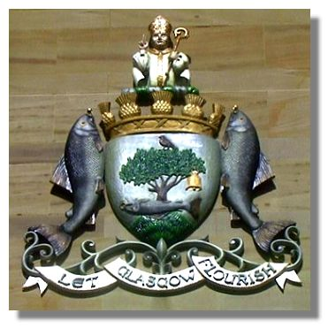

Saint Kentigern lived from 528 to 13 January 614. He is the patron saint and founder of the City of Glasgow.

St Kentigern’s mother was Princess Theneva daughter of King Loth. After an illicit encounter with her cousin she fell pregnant. Her father was so outraged he banished her from his kingdom and cast her adrift in a boat without oars on the River Forth. She drifted up-river and came ashore at Culross in Fife, where Kentigern was born.

Kentigern was given the name Mungo, meaning something like "dear one", by St Serf, who ran a monastery at Culross and took in both mother and son. St Serf then oversaw Mungo's upbringing. At the age of 25, Mungo began his missionary work on the banks of the River Clyde. Here he was welcomed by people previously converted to Christianity by St Ninian, and here Mungo built his church, close to the confluence of the River Clyde and the Molendinar Burn. Since the 1200s the site of this early church has formed part of Glasgow Cathedral.

Mungo worked on the banks of the River Clyde for 13 years until the anti-Christian King Morken of Strathclyde drove him out in about AD565. Mungo made his way through Cumbria to Wales, where he spent time with St David, possibly founded a cathedral at St Asaph, and even found time for a pilgrimage to Rome.

In the 570s King Rhydderch Hael of Strathclyde, having overthrown Morken, invited Mungo to become Archbishop of Strathclyde. Mungo returned to the River Clyde, where his church became the focus of a large community that became known as Clas-gu or "dear family". From these beginnings emerged the modern city of Glasgow.

It was at Clas-gu that Mungo was visited by Saint Columba, who at the time was working as a missionary in central Scotland. It was here, too, that Mungo died on Sunday 13 January 614. He was buried close by his church, and today his tomb lies in the centre of the Lower Choir of Glasgow Cathedral, probably on the actual site of his grave.

In order to make someone a Saint, it was necessary to proved that the candidate had performed miracles during their lifetime. St Mungo was said to have preformed four, referred to in a poem:

Here is the bird that never flew

Here is the tree that never grew

Here is the bell that never rang

Here is the fish that never swam

In the first, he is said to have restored life to the pet robin of St Serf, which had been killed by some of his fellow classmates in Culross, hoping to blame him for its death. In the second he used branches of a tree to restart a fire at St Serf's monastery that had gone out because Mungo had fallen asleep while he was meant to be watching it. The third relates to a miraculous bell he brought back with him from Rome. And the fourth involved the story of Queen Languoreth of Strathclyde being accused of infidelity by her husband, King Riderich, who alleged she had given her wedding ring to her lover when, in reality, the king had himself thrown it into the river. Facing execution, the Queen appealed to St Mungo, who ordered a servant to catch a fish from the river. When the fish was cut open, the ring was found inside, demonstrating the Queen's innocence.

Today the bird, tree, bell and fish form the four elements of the crest of Glasgow City Council. St Mungo is also responsible for the motto of his city, based on his original prayer: "Lord let Glasgow flourish through the preaching of thy word and praising thy name." Since 1699 this has been shortened to "Let Glasgow flourish".

1. Where and when was St Kentigern born?
2. Who changed St Kentigern’s name and what was it changed to?
3. Where did St Kentigern build his church?
4. Where does the word Glasgow come from?
5. What does it mean?
6. What were the requirements for becoming a Saint?
7. Describe the events that allowed St Kentigern to become a Saint?
8. What is Glasgow’s motto?
9. When did St Kentigern die and where is he buried?
10. Complete ‘ Coat of Arms’ activity.

**COAT OF ARMS**  
Cut around the coat of arms. Colour appropriately. Use a ruler to draw a line and label each part.

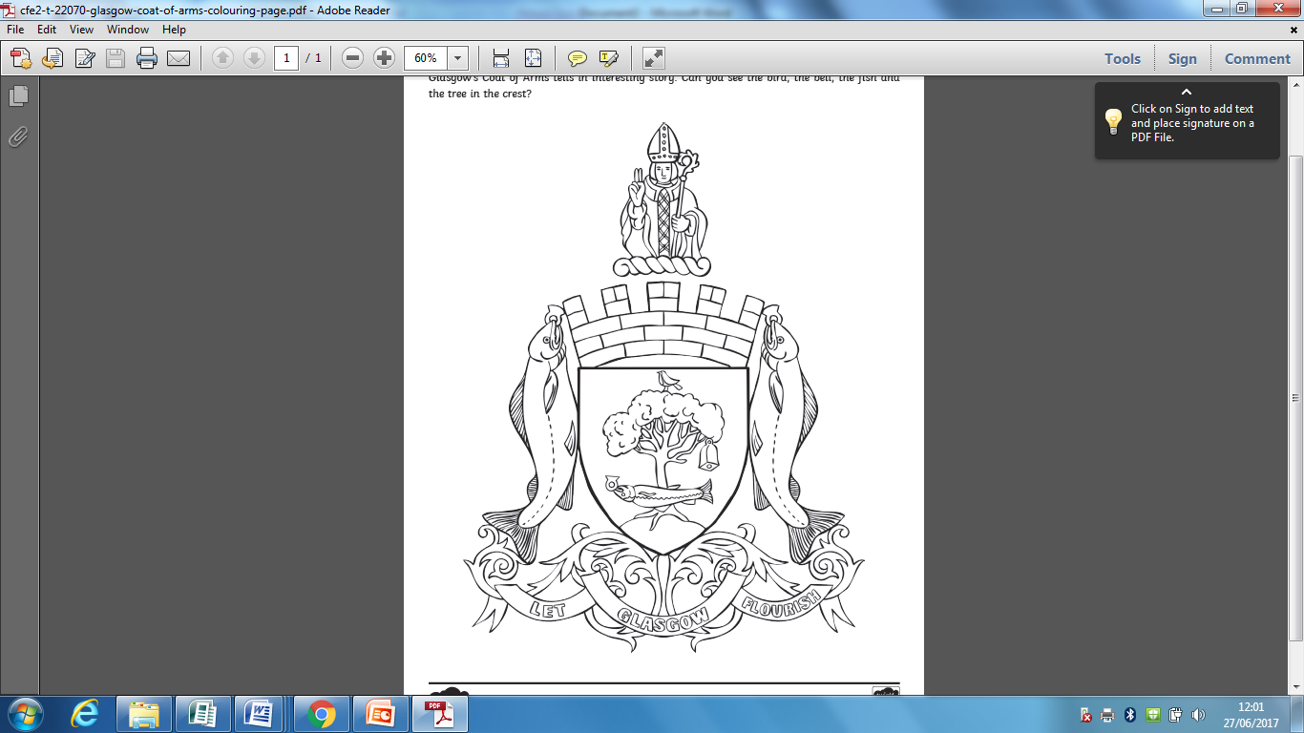

****St. Kentigern lived during the 6th and 7th centuries and is the patron saint of the Church of Glasgow which he founded. According to legend he was illegitimately conceived by Princess Theneva who was punished by her father by being cast off a hill top and then set adrift in the sea. She eventually landed at Culross where she and the child were cared for by St. Serf. Kentigern was given the name Mungo, meaning "dear one".

At the age of 25, Mungo began his missionary work on the banks of the River Clyde; it was here that he built his church where the River Clyde and the Molendinar Burn came together. Since the 1200s the site of this early church has formed part of Glasgow Cathedral.

Mungo worked on the banks of the River Clyde for 13 years until the anti-Christian King Morken of Strathclyde drove him out. During this time Mungo made his way through Cumbria to Wales, where he spent time with St David and went on a pilgrimage to Rome.

In the 570s King Rhydderch Hael of Strathclyde invited Mungo to become Archbishop of Strathclyde. Mungo returned to the River Clyde, where his church became the focus of a large community that became known as Clas-gu or "dear family". From these beginnings emerged the modern city of Glasgow.

St. Kentigern is associated with four symbols which represent some of his miracles, the bird, the tree, the bell and the fish. The bird is the robin he brought back to life, the tree refers to an incident when he let the fire go out and was able to light it again by taking branches from a tree, the bell he is thought to have brought from Rome and it was used to mourn the dead but the best story of all is the fish. A local queen suspected of infidelity by her husband was to be put to death. The King demanded she show her ring which he claimed she had given to her lover; in fact he had thrown into the River Clyde. Kentigern ordered someone to catch a fish from the river and he opened it to produce the ring inside, thereby saving her life.

St Mungo died in the early 7th century and the current Glasgow Cathedral is built on the spot where he was laid to rest. Today the bird, tree, bell and fish form the four elements of the crest of Glasgow City Council. St Mungo is also responsible for the motto of his city, based on his original prayer: "Lord let Glasgow flourish through the preaching of thy word and praising thy name." Since 1699 this has been shortened to "Let Glasgow flourish".

1. Where was St Kentigern born?
2. Who changed St Kentigern’s name?
3. What was his name changed to?
4. Where did St Kentigern build his church?
5. Where does the word Glasgow come from?
6. What does it mean?
7. What did you need to do to become a Saint?
8. List what St Kentigern did to become a Saint?
9. What is Glasgow’s motto?
10. Complete ‘Coat of Arms’ activity.

**COAT OF ARMS**  
Cut around the coat of arms. Colour appropriately. Use a ruler to draw a line and label each part.

